This task was developed by high school and postsecondary mathematics and agriculture sciences educators, and validated by content experts in the Common Core State Standards in mathematics and the National Career Clusters Knowledge & Skills Statements. It was developed with the purpose of demonstrating how the Common Core and CTE Knowledge & Skills Statements can be integrated into classroom learning – and to provide classroom teachers with a truly authentic task for either mathematics or CTE courses.

**TASK**: **DAIRY BARN**

|  |
| --- |
| **TARGET COMMON CORE STATE STANDARD(S) IN MATHEMATICS**: |
| **A.CED.2** Create equations in two or more variables to represent relationships between quantities; graph equations on coordinate axes with labels and scales.* |
| **N.Q.1** Use units as a way to understand problems and to guide the solution of multi-step problems; choose and interpret units consistently in formulas; choose and interpret the scale and the origin in graphs and data displays.* |
| **N.Q.3** Choose a level of accuracy appropriate to limitations on measurement when reporting quantities.* |
| **6.RP.3b** Solve unit rate problems including those involving unit pricing and constant speed. *For example, if it took 7 hours to mow 4 lawns, then at that rate, how many lawns could be mowed in 35 hours? At what rate were lawns being mowed?* |
| **6.RP.3d** Use ratio reasoning to convert measurement units; manipulate and transform units appropriately when multiplying or dividing quantities. |
| **7.G.6** Solve real world and mathematical problems involving area, volume and surface area of two and three dimensional objects composed of triangles, quadrilaterals, polygons, cubes, and right prisms. |
| **TARGET STANDARDS FOR MATHEMATICAL PRACTICES** |
| **MP 1** Make sense of problems and persevere in solving them. |
| **MP 2** Reason abstractly and quantitatively. |
| **MP 4** Model with mathematics. |
| **MP 6** Attend to precision. |
| **TARGET COMMON CORE STATE STANDARD(S) IN ELA/LITERACY**: |
| **RST.9-10.1** Cite specific textual evidence to support analysis of science and technical texts, attending to the precise details of explanations or descriptions. |
| **RST.9-10.2** Determine the central ideas or conclusions of a text; trace the text’s explanation or depiction of a complex process, phenomenon, or concept; provide an accurate summary of the text. |
| **RST.9-10.3** Follow precisely a complex multi-step procedure when carrying out experiments, taking measurements, or performing technical tasks, attending to special cases or exceptions defined in the text. |
| **RST.9-10.5** Analyze the structure of the relationships among concepts in a text, including relationships among key terms (e.g., force, friction, reaction force, energy). |
| **RST.9-10.7** Translate quantitative or technical information expressed in words in a text into visual form (e.g., a table or chart) and translate information expressed visually or mathematically (e.g., in an equation) into words. |
| **TARGET CAREER AND TECHNICAL EDUCATION (CTE) KNOWLEDGE & SKILLS STATEMENTS:** |
| **AGPG01.02** Practice good record keeping strategies and techniques to accomplish Agriculture, Food, and Natural Resources (AFNR) business objectives. |
| **AGPG01.03** Manage budget, credit, and optimal application of AFNR business assets using generally accepted accounting principles to promote business financial well-being. |
| **AGPG01.04** Assess and manage inventory using AFNR industry concepts and inventory control practices to ensure adequate inventory for business demand. |

|  |
| --- |
| **RECOMMENDED COURSE(S):** |
| **Algebra I or Geometry; Integrated Math I or II; Animal Science; Animal Husbandry; Agribusiness Management** |
| **ADDITIONAL INSTRUCTIONS:** |
| This task requires basic calculation and can be completed in one class period. It may be used as a formative or summative assessment task. |

* Modeling standards appear throughout the CCSS high school standards and are indicated by a star symbol (*).

***About the Common Core State Standards in Mathematics***

The Common Core State Standards (CCSS) for Mathematics are organized by grade level in grades K–8. At the high school level, the standards are organized by conceptual category (number and quantity, algebra, functions, geometry, and probability and statistics), showing the body of knowledge students should learn in each category to be college and career ready, and to be prepared to study more advanced mathematics. The Standards for Mathematical Practice describe ways in which developing student practitioners of the discipline of mathematics increasingly ought to engage with the subject matter as they grow in mathematical maturity and expertise throughout the elementary, middle and high school years. [www.corestandards.org](http://www.corestandards.org)

***About the Common Core State Standards in English Language Arts/Literacy***

The Common Core State Standards (CCSS) for ELA/Literacy are organized by grade level in grades K–8. At the high school level, the standards are organized by 9-10 and 11-12 grade bands. Across K-12 there are four major strands: Reading, Writing, Speaking and Listening, and Language. The CCSS also include Standards for Literacy in History/Social Studies, Science, and Technical Subjects, with content-specific (Reading and Writing) literacy standards provided for grades 6-8, 9-10, and 11-12, to demonstrate that literacy needs to be taught and nurtured across all subjects. [www.corestandards.org](http://www.corestandards.org)

***About the Career Cluster Knowledge and Skill Statements***

As an organizing tool for curriculum design and instruction, Career Clusters™ provide the essential knowledge and skills for the 16 Career Clusters™ and their Career Pathways. It also functions as a useful guide in developing programs of study bridging secondary and postsecondary curriculum and for creating individual student plans of study for a complete range of career options. As such, it helps students discover their interests and their passions, and empowers them to choose the educational pathway that can lead to success in high school, college and career. <http://www.careertech.org/career-clusters/resources/clusters/agriculture.html>. Although not included in this template, all Clusters and Pathways have Foundational Academic Expectations and Essential Knowledge & Skills Statements, which, in some cases, overlap with the Common Core State Standards.

**KEY TERMS**

* Fill sand
* Truckloads
* Unit rates
* Inner / Outer stalls, alleys

DAIRY BARN *– The Task*

You are manager of a dairy farm and are responsible for all aspects of the operation. You have just built a new barn (see diagram below) to which you must add the appropriate level of fill sand bedding for your cows. You must establish the amount of fill sand needed to fill the barn stalls in addition to determining how much sand you will need to order and its cost.

Use the diagram and the following information to answer the questions below.

**North**

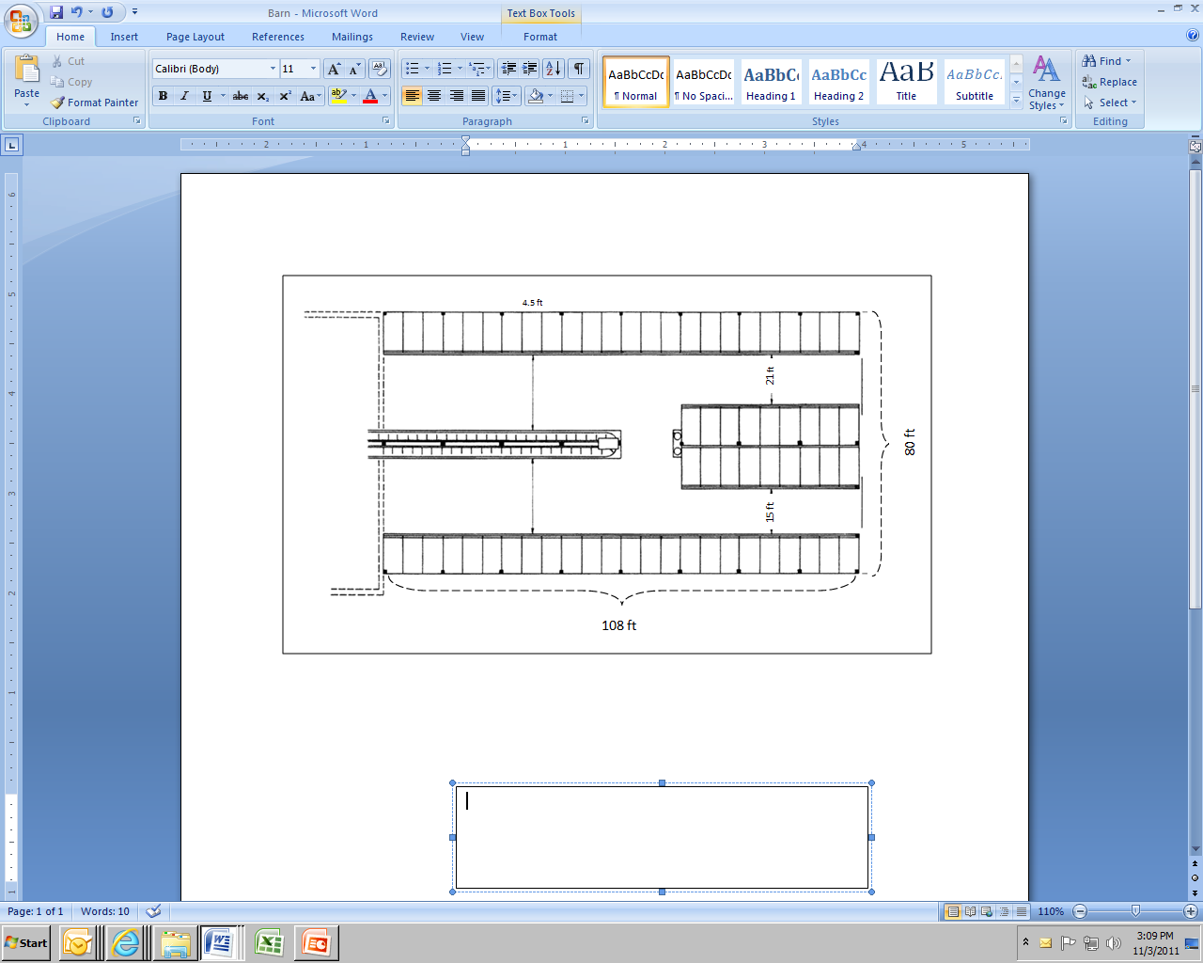

**South**

The Barn is 108 ft by 80 ft.

* The north alley between the inner and outer stalls is 21 ft.
* The south alley between the inner and outer stalls is 15 ft.
* Each stall has the same dimensions, and is 4.5 ft wide.
* Each set of stalls requires a consistent layer of 9 inches of fill sand.
* The alleys are concrete and do not require fill sand.
* Partial truckloads of sand are not available from either supplier.
* Sand must be delivered to your dairy farm. You must include delivery costs in your sand order.

*Show all your work.*

1. What is the overall volume of fill sand required to provide a consistent 9-inch layer for all stalls in cubic feet?
2. Suppliers sell damp sand only by the cubic yard. Convert the number of cubic feet of damp sand required to cubic yards.
3. Supplier A delivers sand in truckloads of 10 cubic yards, and only delivers full truckloads. They charge $7.60 per cubic yard and are located 12.4 miles from your dairy. Supplier A charges $7.50 per loaded mile for delivery. How much with the sand and delivery cost to fill the stalls using Supplier A? Write an equation to show how you will arrive at the cost. Show your work as you solve the equation.
4. Supplier B charges $8.50 per cubic yard and is located 7.6 miles from your dairy. They charge $7.50 per loaded mile for delivery. They have already figured your total cost for sand and delivery charge to be $1,172.50 for 7 truckloads. How many cubic yards will Supplier B deliver per truckload? Write an equation to show how you will determine the number of cubic yards per truckload. Show your work as you solve the equation.
5. Compare total cost for the two different suppliers given. From which supplier will you purchase your fill sand? (Since both suppliers provide quality sand, you will select the lowest priced sand for your operation.) What are your savings?
6. Once the barn has been initially filled, sand only needs to be replaced by a single truckload at a time. For waste management, a total of 2.6 per cubic yards of sand are removed per week. Using Supplier B, how many weeks will go by before you need another truckload?

DAIRY BARN – *Possible Solution(s)*

1. From the given information we conclude the following:

The dimensions of each stall are:

The length of each stall can be found by subtracting the width of the north and south alleys from the total width and dividing by 4 (the number of rows of stalls along the east wall):

80’ – 21’ – 15’ = 44’ 44’ / 4 = 11’ per stall

Width = 4.5’

The depth of the sand is 9 inches, which equals ¾ foot.

The volume of sand needed for each stall = 11’ x 4.5’ x ¾ ‘ = **37.125 ft3 per stall**

We know that there are 24 stalls along each of the north and south walls and 18 total in the inner stalls, for a total of 66 stalls.

The total volume of fill sand needed in cubic feet is 37.125 ft**3** x 66 = **2450.25 ft3.**

1. One cubic yard equals 27 cubic feet. Using unit analysis:

 **90.75 yd3**

1. We need about 91 cubic yards but since Supplier A only delivers full truckloads of 10 cubic yards each, we will need to decide whether to order 9 truckloads, which is a little short, or 10 truckloads, which is too much.

If 9 truckloads are ordered the barn will be 0.75 yd3 short of sand:

0.75 yd3 = 20.25 ft3

The shortage of 20.25 ft3 can be interpreted two ways:

1. One stall will not have enough sand – solving the equation for D (depth of the sand)

4.5’ x 11’ x D = 20.25 ft3

49.5 ft2 x D = 20.25 ft3

D = 20.25 ft3 / 49.5 ft2 = .409… ft, = 4.9 inches of sand

This means that one stall would be short by 4.1 inches of sand. This is likely inadequate, making the stall not usable.

1. All the stalls will have less than 9 inches of sand – solving the equation to determine the overall depth of sand using 90 yd3 or 2430 ft3

66 stalls x 4.5’ x 11’ x D = 2430 ft3

3267 ft2 x D = 2430 ft3

D = 2430 ft3 / 3267 ft2 = .7438… ft = 8.93 inches of sand per stall. (This is very close to the 9 inches required so may be adequate.)

The student will need to make a decision regarding the number of loads to order from Supplier A.

Cost of sand per truckload: $7.60/yd3 x 10 yd3 = $76.00

Delivery per truckload: 12.4 mi x $7.50 per mi = $93.00

Total per truckload: $169.00

The equation will be:

Let T = the number of truckloads and C = total cost in dollars

C = 76T + 93T = 169T

TOTAL FOR 9 Truckloads from Supplier A: **$1521.00** TOTAL FOR 10 Truckloads from Supplier A: **$1690.00**

1. Assuming that Supplier B is planning to send 90.75 yd3, we can use unit analysis and proportional reasoning to determine the number of cubic yards per truckload:



7*x* = 90.75

*x* = 12.96…

So Supplier B will deliver approximately **13 yd3 per truckload**.

1. We know the total costs for Supplier A are either $1521 (for 9 loads, or 90 ft3) or $1690 (for 10 loads, or 100 ft3). The cost quoted by Supplier B of $1172.50, which the supplier indicates is enough sand to meet our needs, is lower than the cost for Supplier A, regardless of whether 9 or 10 loads are ordered. Therefore the sand should be ordered from Supplier B.

The differences would be $1521 – $1172.50 = **$348.50** OR $1690 - $1172.50 = **$517.50**, depending on whether 9 or 10 loads is considered the delivery amount for Supplier A.

1. Since Supplier B has 13 yd3 per truckload, the sand would need to be replaced once the amount removed gets close to that. To find out how many weeks we can use unit analysis:

= **5 weeks**

So Supplier B will need to deliver another 13 yd3 truckload in **5 weeks.** (This assumes that it is acceptable to have less than 9 inches of sand in the stalls during this 5 week period. A delivery in 5 weeks means that the level of sand will become less each week and then brought back up to the desired level with the new delivery.)

DAIRY BARN – *Appendix: Alignment Ratings*

The rating system used in the following charts is as follows:

**3 EXCELLENT ALIGNMENT:**

The content/performance of the task is clearly consistent with the content/performance of the Common Core State Standard.

**2**  **GOOD ALIGNMENT:**

The task is consistent with important elements of the content/performance of the CCSS statement, but part of the CCSS is not addressed.

1. **WEAK ALIGNMENT:**

There is a partial alignment between the task and the CCSS, however important elements of the CCSS are not addressed in the task.

**N/A:**

For Mathematical Practices a content rating does not apply.

## In the charts C = Content Rating and P = Performance Rating

**COLOR KEY**

* **Black** = Part of CCSS/K&S Statement aligned to task
* **Gray** = Part of CCSS/K&S Statement ***not*** aligned to task

## Task-to-Mathematical Practice Alignment Recording Sheet

|  |  |  |  |  |  |
| --- | --- | --- | --- | --- | --- |
| Task Name | Aligned CCSS  Mathematical Practice Standards | C | P | Alignment Comments  (Standards selection, partial alignments, reasons for rating, etc) | Task Comments  (Strengths, weaknesses, possible improvements, effectiveness, etc) |
| DAIRY BARN | **MP** 1 Make sense of problems and persevere in solving them. | **N/A** | **3** | For this task students analyze givens, constraints, relationships, and goals. They must make conjectures about the form and meaning of the solution and plan a solution pathway. They must check the reasonableness of their solution, continually asking themselves, “Does this make sense?” While the task requires routine math, the student must persevere to solve multiple questions that are interdependent. | This is a multi-stage problem with real life applications and considerations. Students must identify quantities and other measures to determine costs, using practical situations, and accurate quantitative calculations. They must show their work at each step of the process. |
| **MP 2** Reason abstractly and quantitatively. | **N/A** | **3** | This task involves quantitative relationships. It requires that students make sense of quantities and their relationships in the problem situation. They must attend to the meaning of the quantities and pay attention to units. Students are asked to do some abstraction since questions 3 and 4 ask them to write equations that represent a given situation and then solve those equations. |
| **MP 4** Model with mathematics. | **N/A** | **3** | Task requires students to translate constraints into equations and to extract information from a geometric model (diagram). They interpret results in the context of the problem. |
| **MP 6** Attend to precision. | **N/A** | **3** | Rounding and estimation are a key part of the thinking that students must use to accurately answer the questions. Students need to calculate accurately and express answers with a degree of precision appropriate for the problem. |

**Task-to-Common Core State Standards Alignment Recording Sheet**

|  |  |  |  |  |  |
| --- | --- | --- | --- | --- | --- |
| Task Name | Aligned CCSS  Content Standards | C | P | Alignment Comments  (Standards selection, partial alignments, reasons for rating, etc.) | Task Comments  (Strengths, weaknesses, possible improvements, effectiveness, etc.) |
| DAIRY BARN | **A.CED.2** Create equations in two or more variables to represent relationships between quantities; graph equations on coordinate axes with labels and scales.* | **3** | **2** | Students must create equations involving cost and the number of truckloads for questions 3 and 4. Graphing is not required in this task. | This complex real-world task combines geometric measurement, unit analysis, and calculation and requires students to show work to support results. |
| **N.Q.1** Use units as a way to understand problems and to guide the solution of multi-step problems; choose and interpret units consistently in formulas; choose and interpret the scale and the origin in graphs and data displays.* | **2** | **3** | There is no requirement in this task for students to choose or interpret the scale and origin in graphs and data displays. |
| **N.Q.3** Choose a level of accuracy appropriate to limitations on measurement when reporting quantities.* | **3** | **3** | This task requires appropriate levels of precision throughout in calculations involving money and measurements. |
| **6.RP.3b** Solve unit rate problems including those involving unit pricing and constant speed. *For example, if it took 7 hours to mow 4 lawns, then at that rate, how many lawns could be mowed in 35 hours? At what rate were lawns being mowed?* | **3** | **3** | Unit rates are used and required throughout the task, for example, cubic yards per truckload, cubic feet per stall, cubic feet per cubic yard, cost per mile, cost per truckload, and cubic yards per truckload. |
| **6.RP.3d** Use ratio reasoning to convert measurement units; manipulate and transform units appropriately when multiplying or dividing quantities. | **3** | **3** | This task requires unit analysis throughout. |
| **7.G.6** Solve real world and mathematical problems involving area, volume and surface area of two and three dimensional objects composed of triangles, quadrilaterals, polygons, cubes, and right prisms. | **2** | **3** | This task involves measures of area and volume for quadrilaterals (a polygon) and right prisms. |

* Modeling standards appear throughout the CCSS high school standards and are indicated by a star symbol (*).

**Task-to-National Career Cluster Knowledge & Skills Statements Alignment Recording Sheet**

|  |  |  |  |  |  |
| --- | --- | --- | --- | --- | --- |
| Task Name | Aligned National Career Cluster Knowledge & Skills Statements | C | P | Alignment Comments | Task Comments |
| DAIRY BARN | **AGPG01.02** Practice good record keeping strategies and techniques to accomplish AFNR business objectives. | **2** | **2** | The task applies a portion of record keeping strategies and techniques to determine the financial implications of the scenario while balancing proper animal husbandry considerations. | The task provides an authentic scenario that requires students to determine cost effectiveness. |
| **AGPG01.03** Manage budget, credit, and optimal application of AFNR business assets using generally accepted accounting principles to promote business financial well-being. | **2** | **2** | The task does not address the credit applications in AFNR business assets, but does provide an opportunity to determine optimal choice to support the scenario. |
| **AGPG01.04** Assess and manage inventory using AFNR industry concepts and inventory control practices to ensure adequate inventory for business demand. | **1** | **2** | The basics of inventory control are applied in the context of this task, but the deeper application of managing inventory is typically in the context of business demand. |